# GUJARAT TECHNOLOGICAL UNIVERSITY

Chandkheda, Ahmedabad

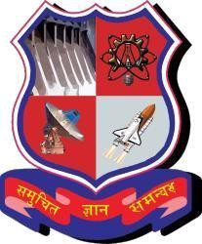Affiliated

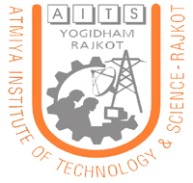

Atmiya Institute of Technology & Science, Rajkot

A Report On

# (TOPIC)

Under subject of DESIGN ENGINEERING –2A

B. E. III, Semester – V (Computer Engineering)

Submitted by: Group:

Sr. Name of student Enrolment No.

1. Sunny A. Sommanek 150033107024

2. Utsav B. Maniar 150033107015

3. Ajay Chauhan 150033107004

4. Krutarth L. Pujara 150033107013

Prof. Nishat Shaikh

(Faculty Guide)

Prof. Dhaval Nimavat

(Head of the Department)

Academic year (2016-2017)

**ATMIYA**

**INSTITUTE OF TECHNOLOGY AND SCIENCE**

**RAJKOT**

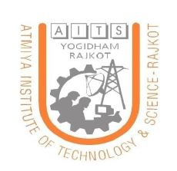

**CERTIFICATE**

Date:

This is to certify that the “**Predicting and Modelling of Social Media”** has been carried out by Sunny A. Sommanek my guidance in fulfillment of the subject Design Engineering-2A in COMPUTER ENGINEERING (5th Semester) of Gujarat Technological University, Ahmedabad during the academic year 2016-17.

GUIDE:

Prof. Nishat Shaikh

**ATMIYA**

**INSTITUTE OF TECHNOLOGY AND SCIENCE**

**RAJKOT**



**CERTIFICATE**

Date:

This is to certify that the “**Predicting and Modelling of Social Media”**has been carried out by Utsav B. Maniar my guidance in fulfillment of the subject Design Engineering-2A in COMPUTER ENGINEERING (5th Semester) of Gujarat Technological University, Ahmedabad during the academic year 2016-17.

GUIDE:

Prof. Nishat Shaikh

**ATMIYA**

**INSTITUTE OF TECHNOLOGY AND SCIENCE**

**RAJKOT**



**CERTIFICATE**

Date:

This is to certify that the “**Predicting and Modelling of Social Media”** has been carried out by Ajay Chauhan my guidance in fulfillment of the subject Design Engineering-2A in COMPUTER ENGINEERING (5th Semester) of Gujarat Technological University, Ahmedabad during the academic year 2016-17.

GUIDE:

Prof. Nishat Shaikh

**ATMIYA**

**INSTITUTE OF TECHNOLOGY AND SCIENCE**

**RAJKOT**



**CERTIFICATE**

Date:

This is to certify that the “**Predicting and Modelling of Social Media”** has been carried out by Krutharth L. Pujara my guidance in fulfillment of the subject Design Engineering-2A in COMPUTER ENGINEERING (5th Semester) of Gujarat Technological University, Ahmedabad during the academic year 2016-17.

GUIDE:

Prof. Nishat Shaikh